**Тестування API за допомогою Postman**

**Рівень 1**

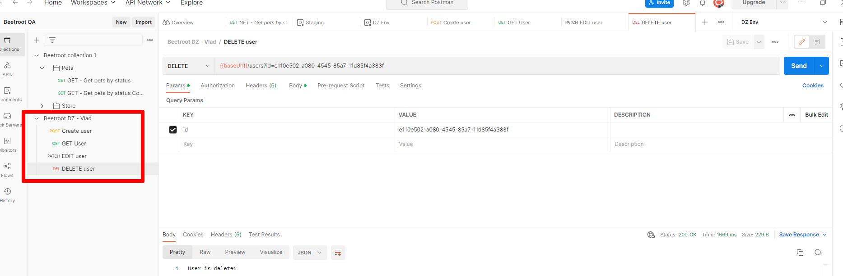

**Separate homework environment**

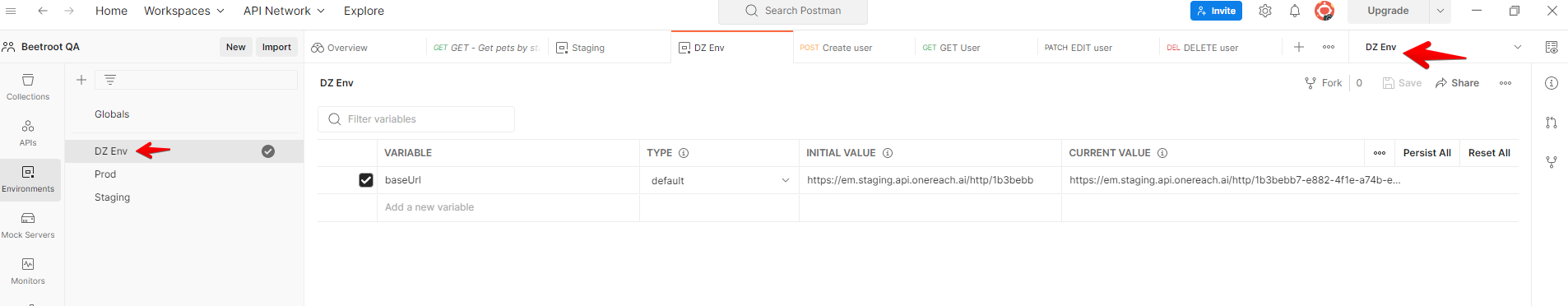

**Link to a postman collection (json file):**

[**https://drive.google.com/file/d/1F5L32kRb2fgT8mfEwqV8oDsHzuaHlVpz/view?usp=share_link**](https://drive.google.com/file/d/1F5L32kRb2fgT8mfEwqV8oDsHzuaHlVpz/view?usp=share_link)

**Environment:**

[**https://drive.google.com/file/d/1w6MqHQCoqEbwyCOiC-PRPo9bW_HSGxUA/view?usp=share_link**](https://drive.google.com/file/d/1w6MqHQCoqEbwyCOiC-PRPo9bW_HSGxUA/view?usp=share_link)

**Рівень 2:**

**Download updated collection with positive and negative cases:**

[**https://drive.google.com/file/d/11c64IzhHFrK8z-K7Tx8p89fgACkd0Mim/view?usp=share_link**](https://drive.google.com/file/d/11c64IzhHFrK8z-K7Tx8p89fgACkd0Mim/view?usp=share_link)